논리회로 플립플롭

컴퓨터공학과 2학년 20191125 박형민

1.

|  |  |  |  |
| --- | --- | --- | --- |
| S R | | Q | /Q |
| 1 | 0 | 1 | 0 |
| 0 | 0 | 1 | 0 |
| 0 | 1 | 0 | 1 |
| 0 | 0 | 0 | 1 |
| 1 | 1 | 0 | 0 |

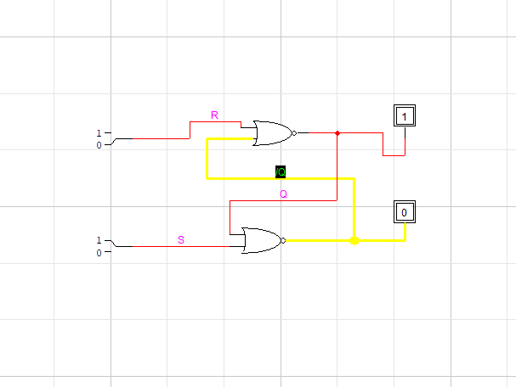

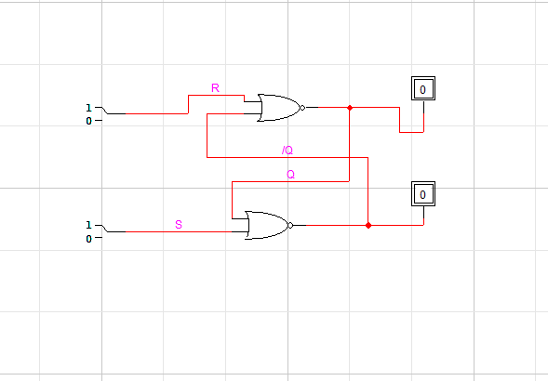

2.

|  |  |  |  |
| --- | --- | --- | --- |
| /S /R | | Q | /Q |
| 1 | 0 | 0 | 1 |
| 1 | 1 | 0 | 1 |
| 0 | 1 | 1 | 0 |
| 1 | 1 | 1 | 0 |
| 0 | 0 | 1 | 1 |

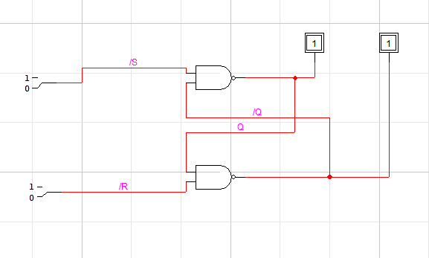

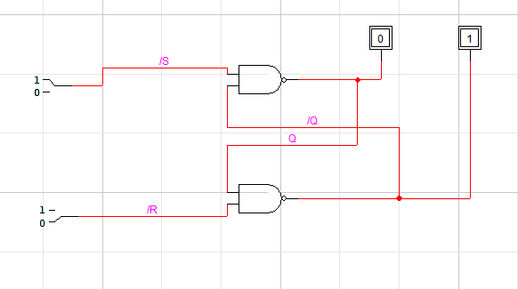

3.

|  |  |  |  |  |
| --- | --- | --- | --- | --- |
| E | S R | | Q | /Q |
| 0 | 0 | 0 | 1 | 1 |
| 0 | 0 | 1 | 0 | 1 |
| 0 | 1 | 0 | 1 | 0 |
| 0 | 1 | 1 | 1 | 0 |
| 1 | 0 | 0 | 0 | 1 |
| 1 | 0 | 1 | 0 | 1 |
| 1 | 1 | 0 | 1 | 0 |
| 1 | 1 | 1 | 0 | 0 |

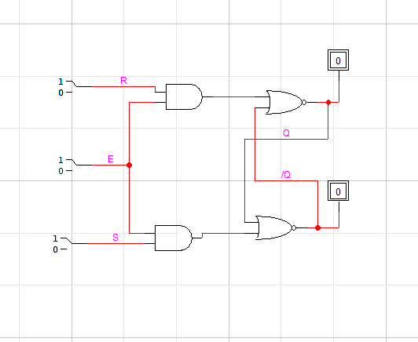

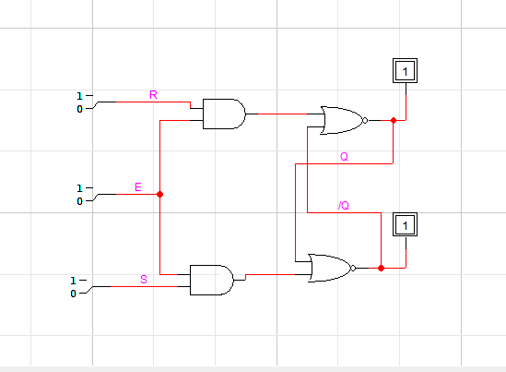

4.

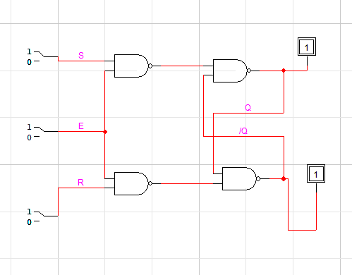

|  |  |  |  |  |
| --- | --- | --- | --- | --- |
| E | S R | | Q | /Q |
| 0 | 0 | 0 | 0 | 1 |
| 0 | 0 | 1 | 0 | 1 |
| 0 | 1 | 0 | 0 | 1 |
| 0 | 1 | 1 | 0 | 1 |
| 1 | 0 | 0 | 0 | 1 |
| 1 | 0 | 1 | 0 | 1 |
| 1 | 1 | 0 | 1 | 0 |
| 1 | 1 | 1 | 1 | 1 |

5.

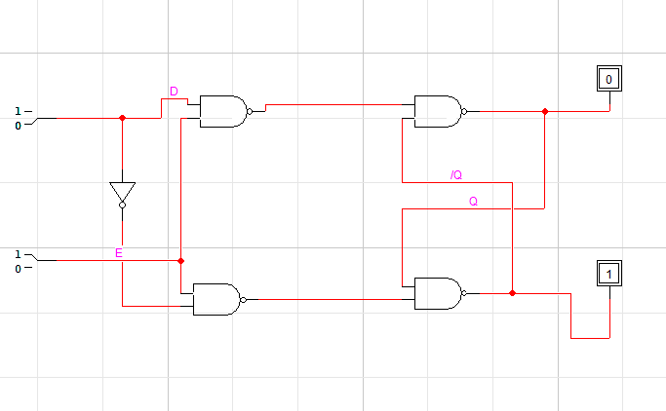

|  |  |  |  |
| --- | --- | --- | --- |
| E Q | | Q | /Q |
| 0 | 0 | 0 | 1 |
| 0 | 1 | 0 | 1 |
| 1 | 0 | 0 | 1 |
| 1 | 1 | 1 | 0 |